Winchester Model 1912 (Model 12)

Pump-Action Slide Shotgun [1912]

The Winchester Model 1912 pump-action shotgun saw use throughout two World Wars, the Korean War and the Vietnam War in US military service.
Authored By: Staff Writer | Last Edited: 08/31/2023 | Content ©www.MilitaryFactory.com | The following text is exclusive to this site.

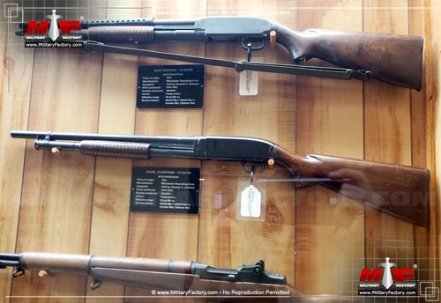

Famous American gunsmith John Moses Browning partnered with the Winchester Repeating Arms Company beginning in 1883 and became responsible for several well-known rifle and shotgun designs during his stay there. The Model 1893 became Winchester's first slide-action shotgun after a lever-action shotgun was introduced in 1887. The Model 1893 was produced in 35,000 examples from 1893 into 1897 in a 12-gauge form. Externally, it featured the familiar squared Winchester-style receiver, a wood stock with integrated pistol grip and wood slide held under a long-running 30-inch metal barrel.
The Model 1893 was inevitably improved through the upcoming "Model 1897" which featured a reinforced receiver (to handle the new smokeless powder shells, a rarity for shotguns of the time) and lengthened shoulder stock. Otherwise, the conventional pump-action slide arrangement remained the same and the receiver still retained the true Winchester-style appearance. At the onset of World War 1 (1914-1918), Winchester had evolved their already-popular Model 1893 line into the "Model 1897". This invariably produced a specially designed variant recognized as the "Trench Gun" to suit a US military requirement for a close-range weapon of exceptional reliability and considerable stopping power. The Model 1897 fit the bill and changes to the design included a shorter 20-inch barrel, a perforated heat shield fitted over the barrel and a special bayonet adapter devised by the specialists at the Springfield Armory. Overall, the weapon remained the same trusted-and-true 12-guage long gun fitting five shells within a tubular magazine under the barrel assembly. The weapon held a unique facility in which the trigger could remain pressed and the gun fired in rapid succession through actuation of the pump slide allowing a well-trained operator to loose all five rounds quickly. In confined placed such as trenched and buildings, this proved an advantage. 1,024,700 Model 1897s were produced and utilized by all US military branches during the war. The weapon, amazingly, went on to see continued service throughout World War 2, the Korean War and the Vietnam War despite its 1890s origination.
In 1912, Winchester engineer Thomas Crosley Johnson took to refining the Browning-inspired Model 1897 series further to produce the "Model 1912" of 20-gauge form. The hammer was now entirely housed within the frame to provide a smoother, cleaner appearance - a standard since adopted by all shotgun manufacturers. The wooden stock was well-formed to incorporate the pistol grip aft of the traditional trigger group. The barrel was tapered with the tubular magazine underslung in the usual way. A ribbed slide was set over this installation and operated in a conventional fashion. Shells were loaded through a port under the receiver and each manually-actuated pump of the slide would introduce a new shell into the chamber while ejecting any spent shells out of a right-side port on the receiver. Construction was primarily of steel with metal components machined and furniture of wood. Certainly a very refined weapon, it was a further evolution of the line of Winchester shotguns originating from 1893. The Model 1912 retained the quick-firing trigger-pump "function" of the Model 1897 before it. In 1914, a 12- and 16-guage Model 1912 became available with the 12-guage form managing six shells from the tubular magazine.
For the United States military in World War 1, the Model 1912 appeared in a fully-militarized form mimicking the changes as forced upon the Model 1897 Trench Gun (shorter barrel, heat shield and provision for a bayonet). Form and function were largely unchanged from the civilian version of the shotgun, the action remaining manual through operation of the slide and trigger. The US Army alone procured 20,000 of the type (designated as the "Model 12" or "M12") when going to war in Europe in 1917. As "trench guns" they served their purpose, supplying exceptional hitting power within short ranges resulting in German protests of the use of such weapons by war's end - ironic considering the use of poison gas by the Germans against the Allies in the same war. Trench guns were named after the trench warfare emerging during the early years of World War 1, bogging down a once fluid, mobile fronts into warzones of bloody attrition and stalemate. World War 1 ended with the German surrender in November of 1918, the original Model 12 Trench Guns being produced into the early 1920s.©MilitaryFactory.com

By the time of American involvement in World War 2, the Model 12 was slightly altered to feature a simpler heat shield containing four rows of holes but was more or less the same weapon. A further 80,000 examples were ordered when America went to war in December of 1941 and they quickly found homes in all branches of the US military once again - though its value was heightened in the Pacific by US Marines who favored it in jungle warfare. There proved an appreciation in its use for close-quarters combat where personnel were charged with clearing out enemy tunnels, choke points, rocky mountain overlooks and thick jungle settings from fanatical and stubborn Japanese defenders. As such, weapons like shotguns and submachine guns were held in great respect in this theater of war, particularly if utterly reliable under the abuses of combat which many American-made shotguns were. The 12-guage slug held more than enough in stopping the average man either charging the operator or unwilling to give up his position. Beyond the base shooting model and the militarized trench gun models, Winchester also delivered "Riot Gun" versions with shorter barrels (sans bayonet mounting and heat shield) for security duty at American bases and ports. Still others were purchased by the US military for training aerial gunners in the fine art of downing enemy aircraft in budget.
Successful exposure of the Model 12 in World War 2 no doubt opened its use to further combat in the upcoming Korean War (1950-1953) as many remained in circulation after World War 2. In fact, many World War 2-era weapons saw extended combat service in this fashion and the Model 12 proved no different. US personnel still relied on the inherent firepower of their tried-and-true shotguns when coming up close to North Korean and Chinese enemies and Model 12 rarely disappointed if at all. It was only by the time of the Vietnam War that stocks of Model 12s were becoming depleted in the US military inventory and the high production and procurement costs of the Model 12 made it susceptible to budgetary constraints to which the Winchester product eventually superseded by the competing product lines in the same role. It was only cost that ultimately slowed the Model 12 down.
The Model 12 line was further expanded by Winchester to include all manner of civilian/sporting market forms including skeet shooters, trap shooters and various special edition/high standard finish models. In all, some 2,000,000 Model 12 shotguns were completed until official production ceased in 1963. Special models were continually released up until 2006 and a 28-guage model eventually joined the family line. Barrel lengths offered throughout her production life included 20-, 26-, 28-, 30- and 32-inches
The Winchester Model 1912/Model 12 came to be known as the "Perfect Repeater" due to its smooth, reliable action.©MilitaryFactory.com

Note: The above text is EXCLUSIVE to the site www.MilitaryFactory.com. It is the product of many hours of research and work made possible with the help of contributors, veterans, insiders, and topic specialists. If you happen upon this text anywhere else on the internet or in print, please let us know at MilitaryFactory AT gmail DOT com so that we may take appropriate action against the offender / offending site and continue to protect this original work.

Specifications

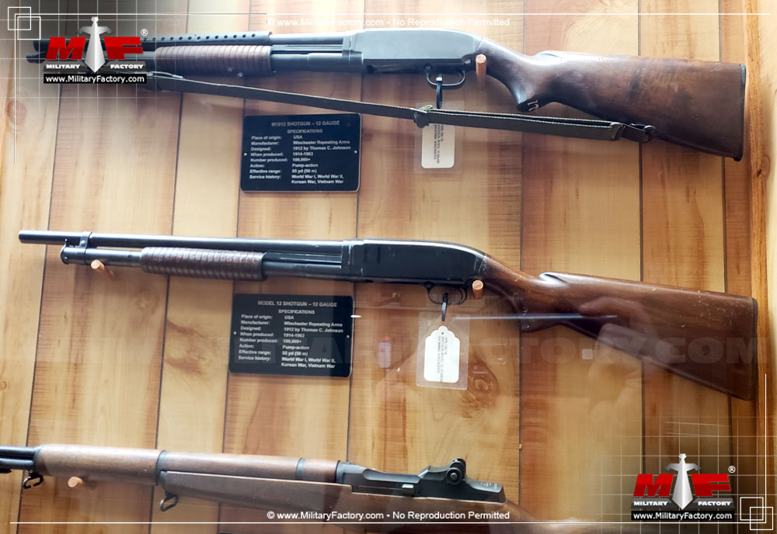
Image copyright www.MilitaryFactory.com; No Reproduction Permitted.
❮❯

